|  |  |  |
| --- | --- | --- |
| **FACULTY OF TECHNOLOGY MANAGEMENT AND TECHNOPRENEURSHIP (FPTT)**  **UNIVERSITI TEKNIKAL MALAYSIA MELAKA (UTeM)** | | |
| **TECHNOLOGY ENTREPRENEURSHIP** | | |
| **BTMW 4012** | **SEMESTER I** | **2022 /2023** |
| |  |  |  |  |  | | --- | --- | --- | --- | --- | | **CO** | **PO** | **C** | **P** | **A** | | **2** | **10** |  |  | 3 |  |  |  |  |  | | --- | --- | --- | --- | | **Test** | **Practical Work** | **Business Project Report** | **Business**  **Plan** | |  | 1 |  |  |   **EVALUATION RUBRIC FOR BUSINESS SALES (INDIVIDU)**  **TOTAL 15%** | | |
| **Instructions for Individual Task 1: Practical Work (15%)**   1. This task is an individual assignment. 2. Students need to update your current sale from time to time. 3. Please click to : [**https://www.go-ecommerce.my**](https://www.go-ecommerce.my) for registration. 4. Fulfill all the necessary information in the Go-eCommerce platform.    1. For this question,     Matrix No: Example B06XXXXXX   * 1. click “Student at TVET/University”      1. Students need to update your current sale from time to time. 2. Please refer to the assessment rubric for further details about the marks. 3. Submission date for Business Sales Report on **18 November 2022 (Friday) before 5 pm** | | |

**EXAMPLE: REPORTING FORMAT FOR INDIVIDUAL BUSINESS SLAES**

**(15 % MARKS)**

1. **Cover Page**

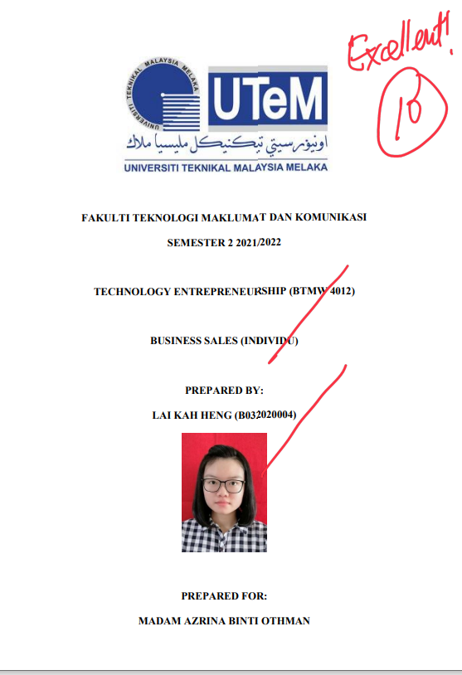

1. **Sales Summary Table**

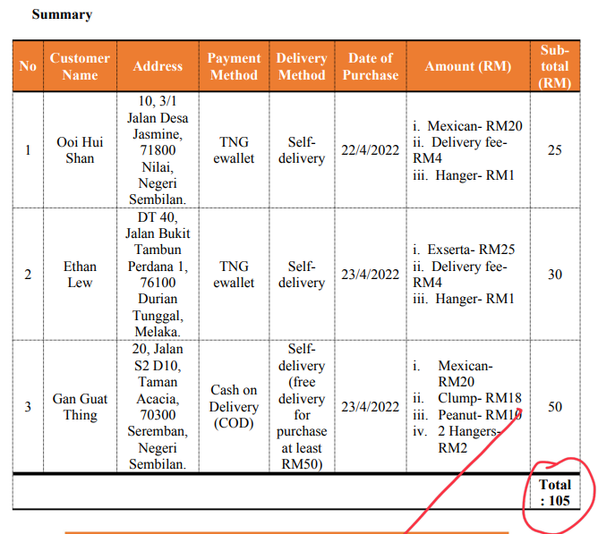

1. **Sales Evidence**

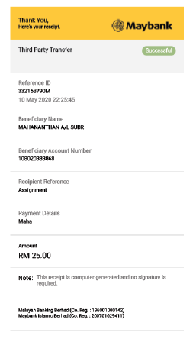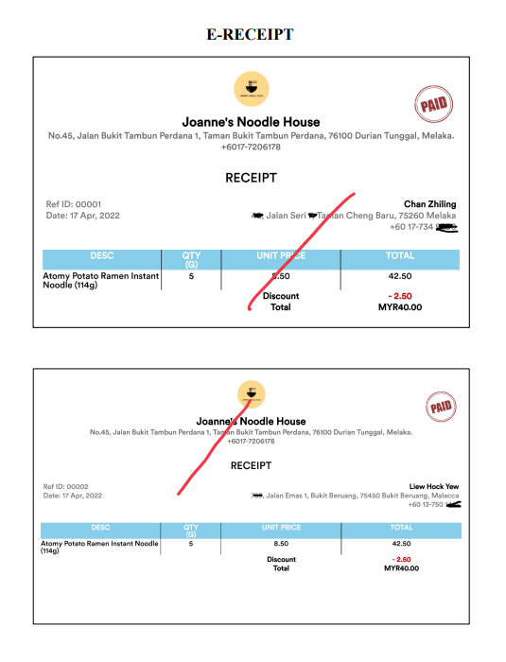

1. **Go-eCommerce Report (Print Screen)**

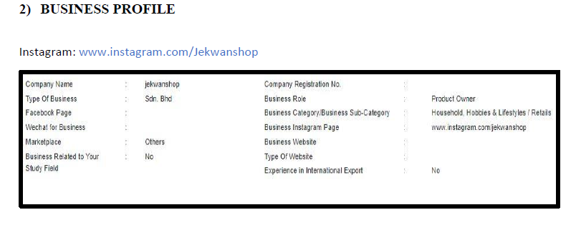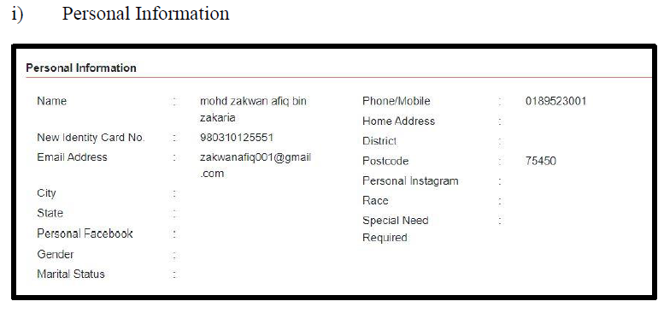

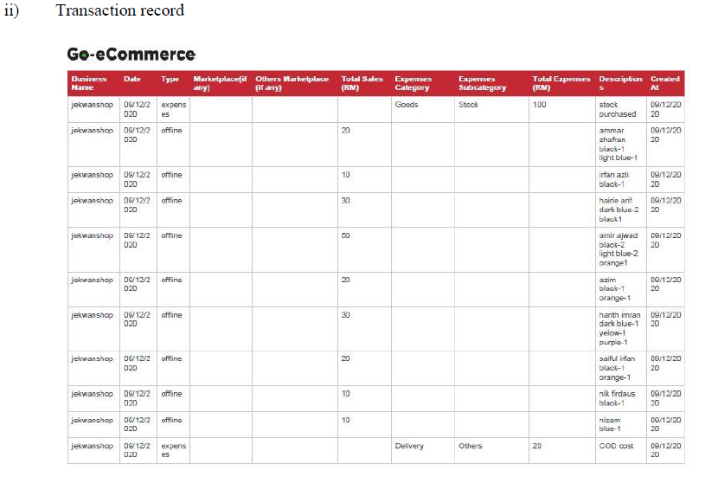

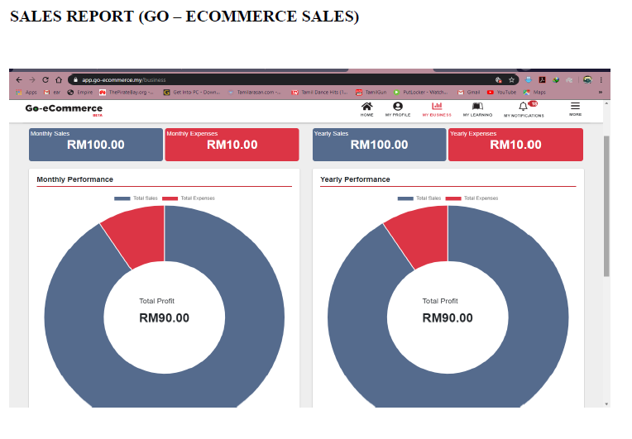

|  |  |  |
| --- | --- | --- |
| **FACULTY OF TECHNOLOGY MANAGEMENT AND TECHNOPRENEURSHIP (FPTT)**  **UNIVERSITI TEKNIKAL MALAYSIA MELAKA (UTeM)** | | |
| **TECHNOLOGY ENTREPRENEURSHIP (BTMW 4012)** | | |
| **STUDENT NAME:** | **LECTURER NAME:** | **SEM I SESSION 2022/ 2023** |
| **MATRIX NO:** | **FACULTY: PROGRAM:** | **YEAR:** |

**EVALUATION RUBRIC FOR BUSINESS SALES 15%**

|  |  |  |  |  |  |  |  |  |  |
| --- | --- | --- | --- | --- | --- | --- | --- | --- | --- |
| **Criteria** | **Marks** | **Worst** | **Poor** | **Moderate** | **Satisfactory** | **Good** | **Excellent** | **A** | **Marks Obtained (%)** |
| **Sales report** | **7 marks** | **0 mark** | **1.4 mark** | **2.8 mark** | **4.2 marks** | **5.6 marks** | **7 marks** | **A3** |  |
| Unable to provide any sales report | Able to provide minimal sales of RM 10 | Able to provide sales of RM 10.01 - RM 20 | Able to provide sales of RM 20.01 - RM 40 | Able to provide sales of RM 40.01 - RM 60 | Able to provide total sales of **RM61** and above |
| **5 marks** | **0 mark** | **1 mark** | **2 mark** | **3 marks** | **4 marks** | **5 marks** | **A3** |  |
| Unable to provide evidence | **Poor** evidence of sale record (customer’s name ONLY) | Able to provide **moderate** customer information (customer’s name, address, payment method and delivery method – tracking no) | Able to provide **satisfactory** customer information (customer’s name, address, payment method and delivery method – tracking no) | Able to provide **good** customer information (customer’s name, address, payment method and delivery method – tracking no) | Able to provide **excellent** customer information (**customer’s name, address, payment method and delivery method – tracking no**) |
| **Go-eCommerce** | **3 marks** | **0 mark** | **0.6 mark** | **1.2 mark** | **1.8 marks** | **2.4 marks** | **3 marks** | **A3** |  |
| Unable to provide sales record at Go-eCommerce Platform | **Poor** evidence of sale record (print screen from Go eCommernce Platform) | Able to provide **moderate** evidence of sale record (print screen from Go eCommernce Platform) | Able to provide **satisfactory** evidence of sale record (print screen from Go eCommernce Platform) | Able to provide **good** evidence of sale record (print screen from Go eCommernce Platform) | Able to provide **excellent** evidence of sale record (print screen from Go eCommernce Platform) |

Comments :__________________________________________________________________________________________________________

Lecturer Name :

Stamp : Date :